**Navigating the Site**

Once the site is running it will take you to the home page.

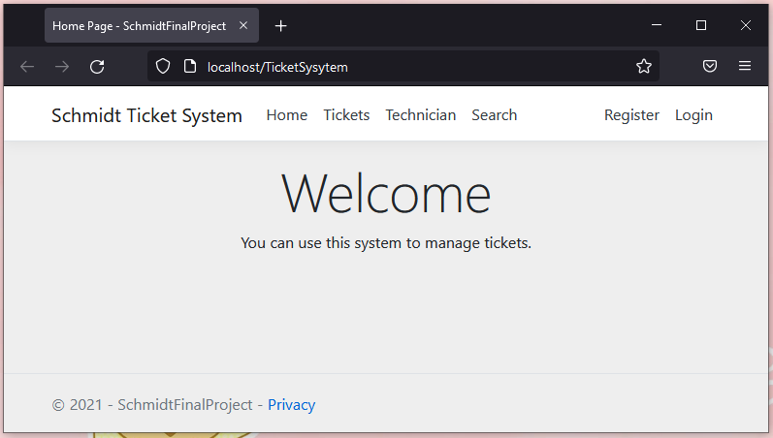

In the navigation bar you will see on the left Home, Tickets, Technicians, and Search. On the right is an area to log-in and register.



You must log in to have authorization to create, edit, or delete data. Click the register button to go to the register screen.

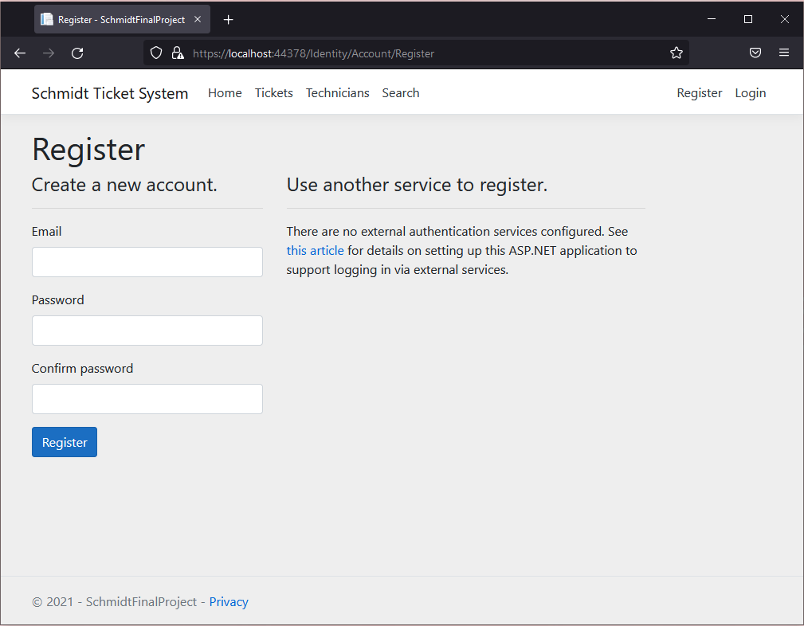

Once you are registered you can log in, click the login button so get to the login screen.

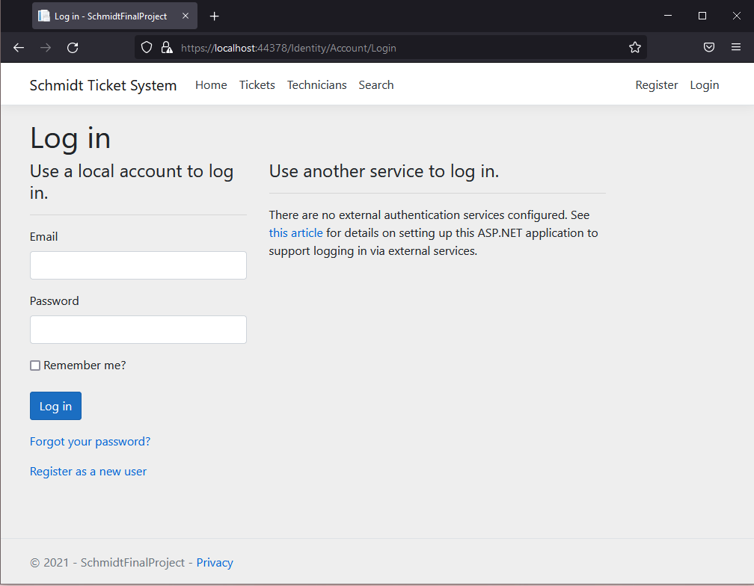

Once you are logged in you will see your email at the top right of the screen along with the log out button.



Now that you are logged in you can create, edit, and delete data.

In the Tickets tab, you can see all the tickets in the database. You are able to create a new ticket. You can also view details, edit, or delete the existing tickets.

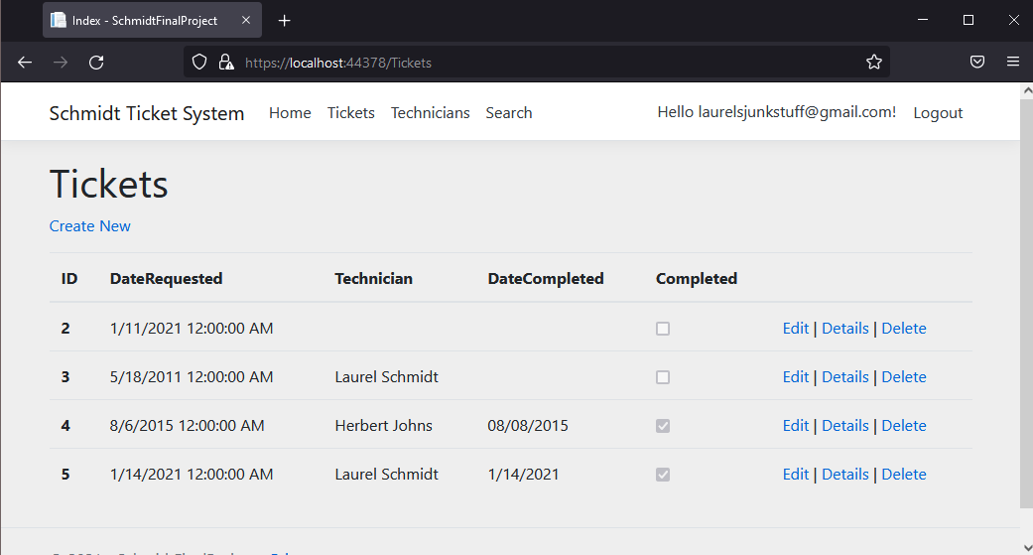

When creating a new ticker, you must fill in the date requested and description section.

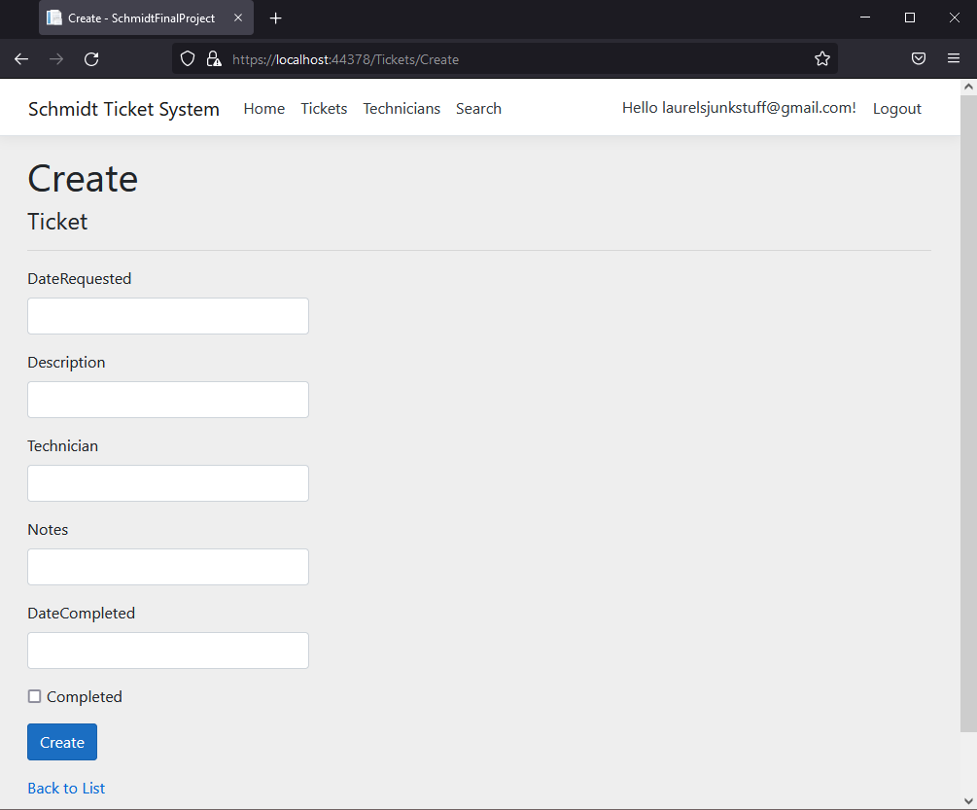

In the Technician tab you can see all of the registered technicians. You can create a new technician. You can also view details, edit, and delete any existing technicians.

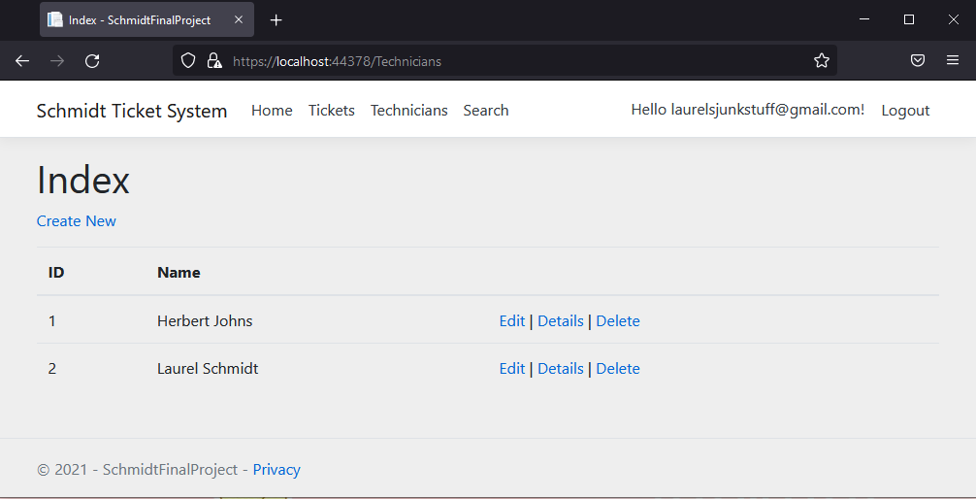

When creating a new technician you must fill in the name section.

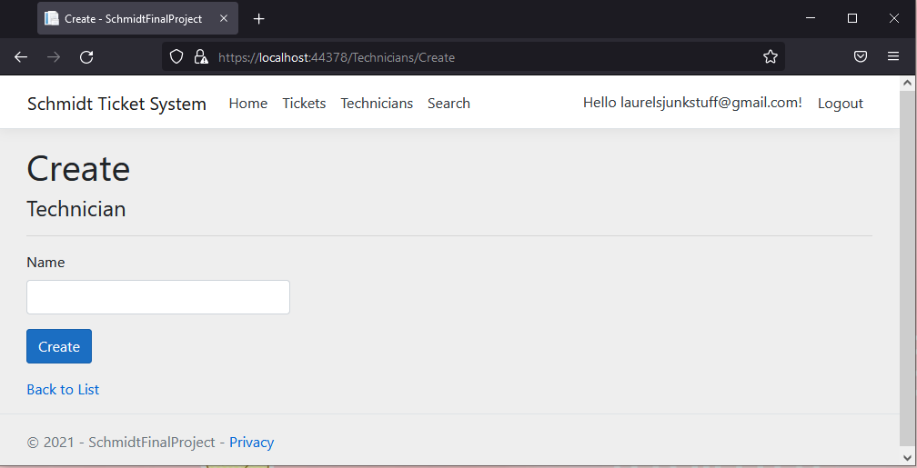

The search tab allows you to search all of the tickets in the database. Enter inputs into any or all of the fields to search.

